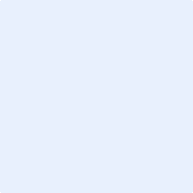

|  |
| --- |
|  |

Name

0

|  |
| --- |
|  |